Performance Characterization of Sun Sensor and Inertial Measuring Unit for the Near Earth Asteroid Scout Mission

D. Bullock[1]

Department of Electrical Engineering, Arkansas Tech University, Russellville, AR, 72801

D. Edberg[2]

Aerospace Engineering Department, California State Polytechnic University, Pomona, CA, 91768

A. Heaton[3]

NASA Marshall Space Flight Center, Huntsville, AL, 35812

B. Stiltner4

Qualis Corporation, Huntsville, AL, 35812

C. Becker5

NASA Marshall Space Flight Center, Huntsville, AL, 35812

B. Diedrich6

Dynamic Concepts Inc., Huntsville, AL, 35812

J. Orphee7

Aerodyne Industries, Huntsville, AL, 35812

At the beginning of its 2018 mission, NASA’s Near Earth Asteroid Scout (NEA Scout) mission must perform two critical maneuvers shortly after separating from its SLS launch vehicle. The first maneuver is to stop all of the spacecraft’s rotation rates that may occur during its separation from the launch vehicle, using angular rate data from an on-board microelectromechanical (MEMS) inertial measuring unit (IMU). Next, the spacecraft will use its on-board sun sensors to locate the sun and carry out its next maneuver: to orient the spacecraft such that the plane of its photovoltaic array is perpendicular to the sun, so that it may charge its batteries. In this report, we provide a detailed description of testing and a summary of the performance characteristics of the sun sensor array and the IMU.

# Introduction

T

HE Near Earth Asteroid Scout (NEA Scout) spacecraft is a 6U CubeSat scheduled for launch on the Space Launch System (SLS) EM-1 in 2018. The objective of the 2.5-year NEA Scout mission is to demonstrate the use of a large, 86 m2 solar sail for primary propulsion system, to rendezvous with a near earth asteroid, and gather photographic and other scientific information such as its size and spin rate. The NEA Scout spacecraft has an onboard science camera that will be used take detailed images of the asteroid’s surface features in hopes of identifying possible landing sites in support of a future manned mission to the asteroid.

The Planetary Systems Corporation’s canisterized satellite dispenser (CSD) system that deploys NEA Scout from the SLS may induce rotational rates as high as 10°/sec in multiple axes. Therefore, spacecraft must perform two maneuvers that are critical to the success of the mission. The first maneuver is to detumble itself after deployment. After the NEA Scout has detumbled, it must locate the sun in order to successfully point the photovoltaic (PV) array that will be used to charge its batteries that provide power to the guidance and navigation system, communications equipment, and scientific instruments. If these early maneuvers are not successful, the mission will likely fail. Both the detumbling and sun-pointing maneuvers use dedicated sensors to achieve the maneuvers’ goals. Since the performance characteristics of these sensors have not been studied, we provide a thorough description of the characterization of the performance of the inertial measuring unit (IMU) and sun sensors in this report.

The NEA Scout uses measurements provided by a Sensonor STIM 300 IMU [1] in order to detumble the CubeSat after deployment. This IMU is a strapdown, microelectromechanical (MEMS) system that contains a three-axis gyroscope for measuring angular rates, a three-axis accelerometer for measuring linear accelerations, and a three axis inclinometer for measuring inclination angles. MEMS-based IMUs are typically small, lightweight, and have minimal power requirements. The STIM 300 footprint is roughly 40 mm × 45 mm × 22 mm, masses 55 grams, and consumes 1.5 watts of power. One drawback of MEMS-based IMUs is that they do suffer from a lack of sensitivity at low rotational rates and small accelerations, when compared to high precision fiber optic gyros. For detumbling, the flight computer reads the rotational rates (~10°/sec per axis after ejection from the CSD system) from the IMU, and then uses a cold-gas thruster system to slow its rotation until the spacecraft is stabilized with negligible rates. One possible problem that may occur during the detumbling maneuver is that although the *initial* rotational rates are expected to be well within the capabilities of the STIM 300, as the thrusters gradually decrease the rates, they will eventually be slow enough that the IMU no longer gives useful information. At this time, the NEA Scout’s star tracker will serve as the spacecraft’s primary inertial sensor after the system has been stabilized.

For the sun-pointing maneuver, the NEA Scout employs three sun sensor packages attached on three different spacecraft surfaces. Each sun sensor package has a set of four silicon (Si) photodiodes that are optimized to be sensitive to wavelengths within the visible spectrum [2]. Each of the four photodiodes produce an electrical signal relative to the intensity of the light that strikes the face of the device. The relative strengths of the signals are then used to calculate a sun vector, which is used to point the photovoltaic array towards the sun in order to charge the onboard batteries.

# Experimental Setup

# IMU Test Setup

The IMU tests were conducted in the Guidance, Navigation, and Control Laboratory facility at the NASA-Marshall Space Flight Center, Huntsville, AL. The test utilized the facility’s Contraves Goerz Corp. high precision three-axis rotational rate table. The three-axis rotational rate table is vibrationally isolated from the building by resting on an independent concrete foundation that is separate from the building’s foundation. The rate table allows the user to program angular rates of up to ±200°/sec for each axis, with an angular rate precision of ±0.00001°/sec.

To test the Sensonor STIM 300 IMU, a custom mounting plate was fabricated by 3D printing to allow the device to be mounted to the center of the rate table. After mounting the device, the appropriate electrical connections were made. In order to communicate with the IMU, a special RS-422 to USB cable was purchased from Sensonor. The USB-RS422 converter cable is a USB to RS-422 levels serial UART converter cable, incorporating FTDI’s (Future Technology Devices International) FT232RQ USB to serial UART interface IC device that handles all the USB signaling and protocols [3]. The cable provides a fast, simple way to connect the IMU module with a RS422 interface to USB. The cable provides both communication and power from a connected laptop that is secured to the top of the rate table. Data were captured and stored using the Sensonor STIM 300 EVK software which allows the user to configure the IMU as well as graphically display gyroscope, accelerometer, and inclinometer data and export the raw data as a text file.

To measure the performance characteristics of the IMU under rotational rates similar to those that will be encountered during the NEA Scout mission, several tests were designed. For each test, carried out in ambient conditions, the IMU was configured to collect gyroscope, accelerometer, and inclinometer data for each axis. To measure the IMU bias, two tests were performed. First, the device was placed on a non-rotating rate table and data were collected from the IMU for 10 seconds, after which the IMU’s power was cycled off and then on. Another bias test was performed for a one hour duration. Subsequent testing measured the run-to-run bias repeatability.

The testing matrix, shown in Table 1, describes the battery of tests that was designed, and each test’s current status. It includes tests for bias, run-to-run bias repeatability, and IMU sensitivity at slew rates that will be experienced on the NEA Scout spacecraft. Additional tests were also designed to measure the IMU’s performance characteristics during multi-axis rotations.

Table 1. **Sensonor STIM 300 IMU Test Matrix**

|  |  |  |  |  |  |
| --- | --- | --- | --- | --- | --- |
| **Test Name** | **Roll (°/sec)** | **Pitch (°/sec)** | **Yaw (°/sec)** | **Description** | **Status** |
| Bias Offset | 0 | 0 | 0 | Measure initial bias offset. Two test were run one for 10 seconds and the other for an hour. | Completed |
| Run-to-Run Bias: Power cycle IMU | 0 | 0 | 0 | Measure run-to-run bias offset | Completed |
| Detumble – Roll | ±10 | 0 | 0 | Measure IMU performance at tumbling rate. | Completed |
| Detumble – Pitch | 0 | ±10 | 0 | Completed |
| Detumble – Yaw | 0 | 0 | ±10 | Completed |
| Min slew rate – Roll | 0.01 | 0 | 0 | Measure IMU performance at the minimum slew rate. | Completed |
| Min slew rate – Pitch | 0 | 0.01 | 0 | Completed |
| Min slew rate – Yaw | 0 | 0 | 0.01 | Completed |
| Max slew rate before sail deployment – Roll | 1 | 0 | 0 | Measure IMU performance at the maximum slew rate prior to solar sail deployment. | Completed |
| Max slew rate before sail deployment –Pitch | 0 | 1 | 0 | Completed |
| Max slew rate before sail deployment–Yaw | 0 | 0 | 1 | Completed |
| Max slew rate with sail deployed – Roll | 0.04 | 0 | 0 | Measure IMU performance at the maximum slew rate with the solar sail deployed. | Completed |
| Max slew rate with sail deployed – Pitch | 0 | 0.04 | 0 | Completed |
| Max slew rate with sail deployed – Yaw | 0 | 0 | 0.04 | Completed |
| Min rate for navigational stability – Roll | 0.0001 | 0 | 0 | Measure IMU performance at the minimum slew rate for navigational stability. | Pending |
| Min rate for navigational stability – Pitch | 0 | 0.0001 | 0 | Pending |
| Min rate for navigational stability – Yaw | 0 | 0 | 0.0001 | Pending |
| Multi-axis rotation performance–Roll+Pitch | 10 | 10 | 0 | Measure IMU performance during multi-axis rotation at detumble rotational rates. | Pending |
| Multi-axis rotation performance–Roll+Yaw | 10 | 0 | 10 | Pending |
| Multi-axis rotation performance Pitch+Yaw | 0 | 10 | 10 | Pending |
| Multi-axis rotation perf. – Roll+Pitch+Yaw | ±10 | ±10 | ±10 | Pending |

To perform this test, the IMU was power cycled and data was taken on the stationary rate table for 10 seconds after the system was rebooted (note the STIM 300 reboot time specification is 0.3 seconds). This test was repeated twenty times in order to obtain an adequate sample size to measure run-to-run bias repeatability. Additional tests were designed to measure the IMU’s sensitivity at the minimum and maximum slew rates for the spacecraft in different configurations: solar sail stowed versus deployed. Further tests were also designed to test the IMU’s performance during multi-axis rotation.

As designated in the right-hand column of Table 1, many of the planned tests were completed. However, due to a critical malfunction of the rate table, not all of the proposed tests were completed. The authors plan to complete the remainder of the testing once the rate table is functional again. According to the point-of-contact for the lab, the timeline for repair may be several months.

**Sun Sensor Test**

The NEA Scout utilizes three sun sensor modules composed of four photodiodes that are sensitive in the visible spectrum from 480 nm to 660 nm with the peak sensitivity occurring at 550 nm. The four photodiodes are each mounted at angles of 25° from vertical and produce an electrical current when light containing wavelengths within the photodiode’s spectral response range strikes its face.

The sun sensor module was tested using a sun simulator that incorporated a 500 W mercury bulb. The sun simulator was mounted on a tripod that allowed for adjustments of height, vertical angle, and azimuthal angle. Additionally, the light intensity was adjusted by connecting the simulator to a variable autotransformer. The sun simulator was configured to measure the performance of the sun sensor array at 0°, 45°, and 90° from vertical. At each vertical position the intensity of the sun simulator was adjusted to mimic the sun light intensity at one Astronomical Unit by measuring the optical power at the face of the photodiode array with a Thor Labs PM100D optical power meter connected to an S130C optical sensor. The sensor is sensitive to wavelengths from 400 nm – 1100 nm, similar to the optical sensitivity of the Si photodiodes.

The sun sensor array was mounted on a 3D printed replica the portion of the NEA Scout body where the sun sensor is to be mounted. To mimic the reflectance of the aluminum body of the CubeSat, the 3D printed replica piece was wrapped with household aluminum foil. The entire assembly was then mounted on a rotation table that allowed for 360° azimuthal rotation. For each sun simulator angle (0°, 45°, and 90° from vertical), the sun sensor data was taken for azimuthal angles from 0° to 180° in 10° increments. The experimental setup is shown schematically in Figure 1.

The electronics on the NEA Scout convert the currents produced by each photodiode into a count that is proportional to the current. To mimic the flight electronics, a circuit was built that converts the current into a voltage using a trans-impedance amplifier (TIA). The TIA is an operational-amplifier (op-amp) based inverting amplifier. In this application each photodiode’s cathode (negative terminal) is connected to the inverting input of an LM324 op-amp (the non-inverting input is grounded). A feedback resistor is connected between the output of the LM324 and the inverting input. This feedback controls the gain of the amplifier. The value of the feedback resistor (22 kΩ) was chosen such that at maximum intensity the voltage output would be below the saturation levels (+5 VDC) of the amplifier. The output voltage is equal to the product of the photodiode current and the feedback resistor.

**Figure 1. Illustration of the experimental setup. Data are taken by rotating the azimuthal angle from 0° to 180° in 10° increments for three different sun simulator angles (0°, 45°, and 90°). The currents generated in the photodiodes are then connected to trans-impedance amplifiers (TIAs) that produce an output voltage proportional to the input currents. The output voltages are then connected to a four channel, 16-bit analog to digital converter that are then sent to a microcontroller on the I2C bus. The microcontroller is then interfaced with a PC to capture the data.**

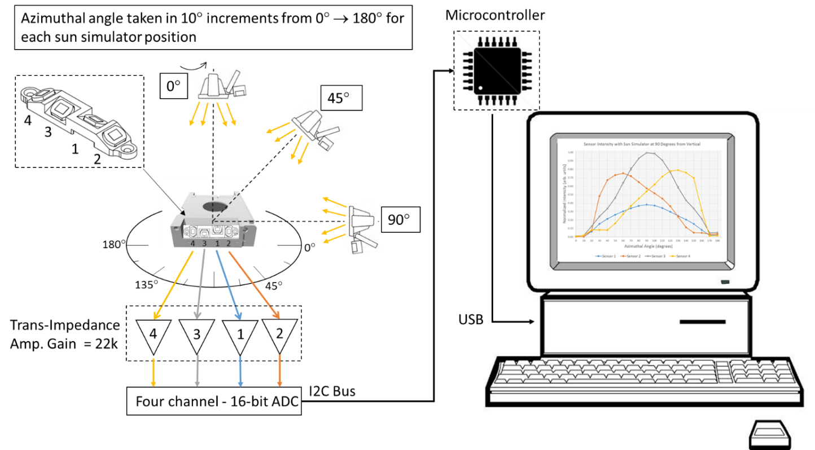

The output voltage from each photodiode is connected to a four channel, 16-bit analog to digital converter (ADC). In this experiment, the ADS1115 was chosen as the ADC. The ADC was powered with +5 VDC which resulted in a 0.125 mV per bit resolution [4]. The ADC was then connected to a microcontroller using the I2C bus. The microcontroller also configured to communicate with a PC using USB port. Data was collected at a rate of 1 Hz. For each angle, 10-20 data points were taken for each of the four photodiodes in the sun sensor array. The data was then averaged, normalized, and plotted.

# Results

**IMU Test Results**

At the writing of this paper, the data collection process is still ongoing. Some preliminary data have been collected regarding the bias, run-to-run bias repeatability, and sensitivity at operational slew rates.

**Sun Sensor Test Results**

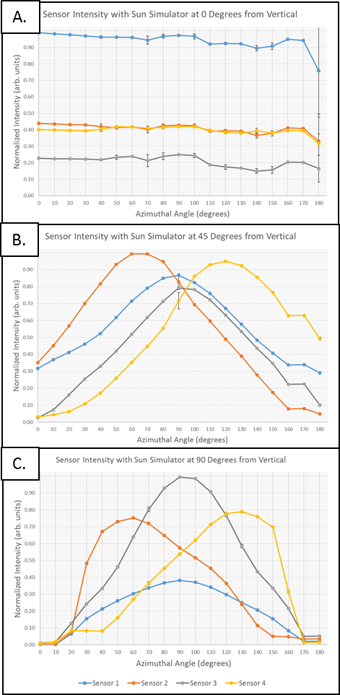

**Figure 2 Normalized sun sensor data for vertical sun simulator angles of 0° (A), 45° (B), and 90° (C).**

Figures 2A, 2B, and 2C show the results from the sun sensor tests with the simulator at 0°, 45°, and 90° from vertical respectively.

In Figure 2A the sun simulator was placed directly above the sun sensor assembly. Photodiode sensor 1 shows the strongest signal followed by sensors 2 and 4 that have roughly the same signal intensity, and signal 3 that has the lowest intensity. As expected, the relative intensity levels remain fairly constant as the sensor is rotated through the different azimuthal angles. However, the signal intensity for all for sensors rapidly decreases at the 180° data point. This is attributed to a slight misalignment error in mounting the sun sensor to the rotational table.

Figure 2B shows the data with the sun simulator at 45° from vertical. These data show that sensors 2 and 4 have the highest relative intensities at 60° and 120° respectively. Also, sensors 1 and 3 reach their maximum values at the same azimuthal angle of 90°.

In figure 2C, sensors 1 and 3 reach their relative maxima at the same azimuthal angle of 90°, while sensors 2 and 4 reach their maxima at 60° and 130° respectively.

# Discussion

The IMU data generated from the rate-table tests will help in characterizing the performance of the device while undergoing rotational rates similar to those that the NEA Scout will experience. The data will yield some important error constants that relate to bias, bias instability, and random walk noise that will be used in a Simulink/MATLAB® model of the IMU currently under development. Additionally, the STIM 300 is scheduled to fly on another mission to the International Space Station (ISS), and the data gathered from the rate-table tests will be shared with the group planning that mission.

The results from the sun sensor test will aid in building a model that can be utilized to ensure the sensor provides correct data to assist the NEA Scout in sun pointing. Additional testing using the current setup will further examine the effects of spurious reflections off of nearby spacecraft components.

# Acknowledgments

The authors would like to thank Don Hediger for his assistance operating the three-axis rate table. Also, the authors would like to thank all of the organizers of the NASA – Marshall Space Flight Center Summer Faculty Fellowship, including Dr. Gerald Karr, Professor Emeritus, University of Alabama – Huntsville; Dr. Frank Six, University Affairs Officer, NASA – Marshall Space Flight Center Academic Affairs Office; Ms. Rachael Damiani, Resource Manager, Alabama Space Grant Consortium – University of Alabama – Huntsville; and Ms. Tina Atchley, Project Coordinator, NASA – Marshall Space Flight Center Academic Affairs Office.

# References

[1] Sensonor, “STIM300 Inertia Measurement Unit,” STIM300 datasheet, Oct. 2015 [TS1524 rev.20].

[2] Hamamatsu, “Si photodiode S768,” S7686 datasheet, Oct. 2002.

[3] Sensonor, “User Manual STIM210/STIM300 Evaluation Kit,” manual, 2015 [DOK412 rev.0].

[4] Texas Instruments, “Ultra-Small, Low-Power, 16-Bit Analog-to-Digital Converter with Internal Reference,”

ADS1115 datasheet, May 2009 [Revised Oct. 2009].

1. Faculty Fellow, Associate Professor of Electrical Engineering, Electrical Engineering, Arkansas Tech University.
2. Faculty Fellow, Professor of Aerospace Engineering, Aerospace, 3801 W. Temple Ave., Pomona, CA 91768.
3. NEA Scout G&C Lead, EV42, NASA-MSFC Building 4600/4212, Huntsville, AL 35812.

   4 NEA Scout GN&C Engineer, NASA-MSFC Building 4600/4215, Huntsville, AL 35812.

   5 Guidance, Navigation & Mission Analysis Engineer, NASA-MSFC Building 4600/4416, Huntsville, AL 35812.

   6 NEA Scout GN&C Engineer, NASA-MSFC Building 4600/4213, Huntsville, AL 35812.

   7 Multi-body Dynamics Engineer, NASA-MSFC Building 4600/4429, Huntsville, AL 35812.